

Post Implementation Review©
For [Project Name]

Document Control

Document Information
© | Information
Document Id | [Document Management System #]
Document Owner | [Owner Name]
Issue Date | [Date]
Last Saved Date | [Date]
File Name | [Name]

Document History
Version | Issue Date | Changes
[1.0] | [Date] | [Section, Page(s) and Text Revised]

Document Approvals
Role | Name© | Signature | Date
Project Sponsor

Project Review Group

Project Manager©

Quality Manager
(if applicable)

Procurement Manager
(if applicable)

Communications Manager
(if applicable)

Project Office Manager
(if applicable)

Table of Contents

Template Guide 1
1 Executive Summary 2
2 Project Performance 2
2.1 Benefits 2
2.2 Objectives 3
2.3 Scope 4
2.4 Deliverables 4
2.5 Schedule 5
2.6 Expenses 5
2.7 Resources 6
3 Project Conformance 6
3.1 Time Management 6
3.2 Cost Management 7
3.3 Quality Management 7
3.4 Change Management 8
3.5 Risk Management 8
3.6 Issue Management 9
3.7 Procurement Management 9
3.8 Communications Management 10
3.9 Acceptance Management 10
4 Project Achievements 11
5 Project Lessons Learnt 11
6 Appendix 11
6.1 Supporting Documentation 11

Template Guide
What is a Post Implementation Review?

A ‘Post Implementation Review’ (PIR) is an assessment of the overall success of the project. The PIR is conducted by closely reviewing the project's performance against the original plans and conformance against the original processes outlined for the project. The purpose of the PIR is not only to assess the projects level of success but also to identify lessons learnt and make recommendations for future projects to enhance their likelihood of success. The PIR results in a formal document which is held as the last record of the project.

The PIR document includes:

- An assessment of how the project performed against the benefits, objectives, scope, deliverables, schedule, expense and resource targets in project planning documentation
- A rating of the level of conformance against each of the project processes, including time / cost / quality / change / risk / issue / procurement / communications and acceptance management
- A full list of the project achievements
- Lessons learnt and recommendations for future projects. ©

When to conduct a Post Implementation Review

The PIR is always constructed at the end of the Project Closure phase, after the Project Closure Report has been approved and all project closure activities completed. Some companies wait for a period after the closure activities have been completed to enable the full business benefits to be realized before the PIR is undertaken. The PIR may be completed by either the Project Manager or (ideally) an independent resource which offers an unbiased opinion of the project's success. The PIR is presented to the Project Sponsor and/or Customer for approval and is also ‘held on file’ for future Project Managers to access and gain the learning generated by the project. ©

How to use this template
This document provides a guide on the topics usually included in a Post Implementation Review. Sections may be added, removed or redefined at your leisure to meet your particular business circumstance. Example tables, diagrams and charts have been added (where suitable) to provide further guidance on how to complete each relevant section.

Executive Summary

Provide an overview of the success of the project, including the:

- Project Performance (against the benefits, objectives, scope, deliverables, schedule, expense and resource targets outlined within the project plan documentation)
- Project Conformance (with time, cost, quality, change, risk, issue, procurement, communication and acceptance processes defined)
- Key Achievements of the project and the Positive Effect on the customer's business
- Lessons Learned from this project and Recommendations for similar future projects.

Project Performance

This section identifies how the project performed against each of the targets identified during the Initiation and Planning phases of the project.

Benefits
List each of the benefits identified in the original Business Case and quantify the level of actual achievement of each benefit, using the following table:

Category | Intended Benefit© | Planned Value | Actual Value
Financial | - New revenue generated  - Reduction in costs  - Increased profit margin | $ x  $ x  $ x | $ x  $ x  $ x
Operational | - Improved operational efficiency  - Reduction in product time to market  - Enhanced quality of product / service | x %  x hrs  x % | x %  x hrs  x %
Market | - Increased market awareness  - Greater market share  - Additional competitive advantage | x %  x %  Describe | x %  x %  Describe

Objectives
List each of the objectives identified in the original Terms of Reference and quantify the level of actual achievement of each objective, using the following table:

Category | Original Objective© | Actual Achievement
Business | - To deliver new accounts payable and receivable and payroll processes, thereby reducing financial processing timescales by at least 30%  - To build brand new work premises with 50% more space, 30 more cark parks, and 20% fewer operational costs than the existing premises  - To provide a new customer complaints service to enable customers to issue complaints on-line and receive a direct response from the company within 24hrs | [Describe]
Technology | - To install new accounts payable and receivable and payroll system modules within the existing accounting system, thereby achieving 99.5% system up-time  - To relocate existing technology infrastructure at the new building premises within 2 days elapsed time and with no impact on customer service delivery  - To build a new website which allows customers to enter and track complaints through to resolution | [Describe]

Scope
Describe the intended scope of the project (from the Terms of Reference) and identify any deviations which occurred, using the following table:

Category | Original Scope© | Deviations
Processes  (affected by the project) | Describe | Describe
Organizational areas
(changed as a result of the project)

Locations
(affected by the project)

Data
(altered due to the project)

Applications
(installed / altered as part of the project)

Technologies
(deployed / decommissioned as part of the project)

Deliverables
List the intended project deliverables as well as their completion criteria / standards (from the Quality Plan) and rate the overall level of achievement for each, using the following table:

Deliverable | Quality Criteria© | Quality Standards | % Achieved
Oracle Financials General Ledger (GL), Accounts Payable (AP) and Accounts Receivable (AR) system modules | System functionality:  - GL tested & installed  - AP tested & installed  - AR tested & installed  - System Performance  - System up-time  - System response-time  - Data migrated | System functionality:  - GL operational (no errors)  - AP operational (no errors)  - AR operational (no errors)  - System Performance  - 99.9% system uptime  - < 5 second response times  - 100% data accuracy | 0 -100%

Schedule
Insert the final project schedule, providing the actual and forecast timescales upon project completion. The following example shows the original baseline timescales only.
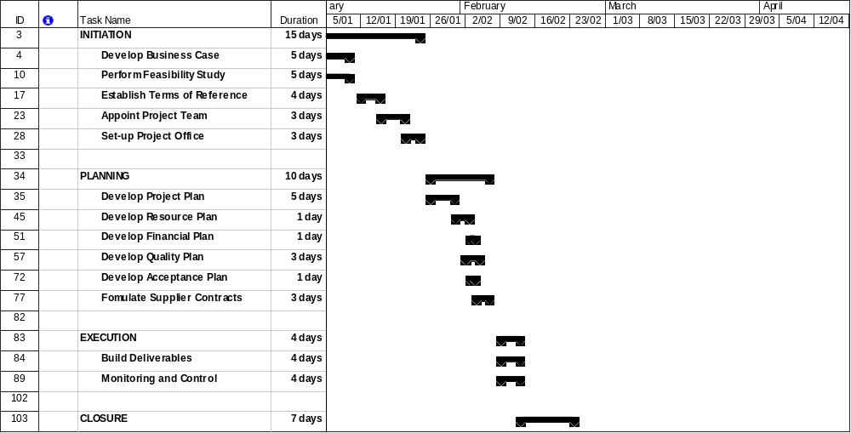

Expenses
Identify the actual expenditure vs. the planned expenditure (from the Financial Plan) within the following table:

Expense Type | Planned Total | Actual Total
Labor  - Project Manager | $ or other currency | $ or other currency
Equipment
- Computers

Materials
- Stationery

Administration
- Legal Fees

Other
Grand Total

Resources
Identify the quantity of resource planned (from the Resource Plan) vs. the actual quantity of resource utilized, within the following table:

Resource Type | Planned Total© | Actual Total
Labor  - Project Manager | Number or total quantity | Number or total quantity
Equipment
- Computer

Materials
- Printer Cartridges

Other
Grand Total

Project Conformance

This section identifies whether or not the project conformed to the processes defined in the Initiation and Planning phases of the project. A number of checklists are provided to determine the actual level of conformance.

Time Management
Identify the level of conformance to the Timesheet Management process identified for the project by completing the following checklist:

Checklist | Y/N
- Was a clear schedule outlined in the Project Plan?  - Were clear effort estimates outlined in the Project Plan?  - Was the Project Plan baselined during the planning phase?  - Was the Project Plan re-baselined at any stage during the project?  - Did all staff record time on a regular timesheet?  - Was the timesheet forwarded to the Project Manager for review?  - Were any timesheet issues raised by the Project Manager?  - Was timesheet information recorded in the Project Plan?  - Was additional time required for any activity?  - Were there any activities with no time recorded against them? © | Y / N

Cost Management
Identify the level of conformance to the Cost Management process identified for the project by completing the following checklist:

Checklist© | Y/N
- Were all expense types identified in the Financial Plan?  - Were all expenses adequately quantified in the Financial Plan?  - Did the project actually incur all expenses planned?  - Were Expense Forms completed for all project expenses?  - Were invoices and receipts kept for expenses incurred?  - Was the Project Manager required to approve all project expenses?  - Were the approval procedures diligently followed?  - Were all expenses recorded in a Project Payments Register?  - Was the Payments Register monitored to assess total expenditure?  - Did the project spend more than the original budget?  - Was the Project Board required to allocate additional funding?  - Was the customer satisfied with the overall level of expenditure? © | Y / N

Quality Management
Identify the level of conformance to the Quality Management process identified for the project by completing the following checklist:

Checklist | Y/N
- Were all project deliverables identified within the quality plan?  - Were clear quality targets identified?  - Were quality criteria and standards specified?  - Were clear Quality Assurance techniques identified?  - Did regular Quality Assurance Reviews take place  - Were clear Quality Control techniques identified?  - Did regular Quality Control take place?  - Were Quality Management Roles formally defined?  - Did staff operate according to their defined Quality Role?  - Were all deliverables recorded within a Deliverables Register?  - Were Quality Review forms completed for all Quality Reviews?  - Were quality deviations formally tracked?  - Were quality improvements actions actually undertaken? © | Y / N

Change Management
Identify the level of conformance to the Change Management process identified for the project by completing the following checklist:

Checklist© | Y/N
- Were all changes managed through the formal change process?  - Were Change Request Forms completed for all changes?  - Were Change Request Forms reviewed by the Change Manager?  - Were Feasibility Studies undertaken for all appropriate changes?  - Did anyone other than the Approval Group approve any changes?  - Were all approved changes implemented as required?  - Were Change Management Roles formally defined?  - Did staff operate according to their defined Change Role?  - Were all changes recorded within a Change Register?  - Did any change impact on the business in an unexpected manner?  - Did any change result in a new risk or issue identified?  - Did any changes result in a new benefit or cost unexpectedly?  - Were all changes applied prior to project closure? © | Y / N

Risk Management
Identify the level of conformance to the Risk Management process identified for the project by completing the following checklist:

Checklist | Y/N
- Were all important project risks identified early in the project?  - Were all risks managed through the formal risk process?  - Were Risk Forms completed for all important risks identified?  - Were all Risk Forms reviewed by the Project Manager?  - Were risk likelihood and impact ratings assigned appropriately?  - Was a clear mitigation plan outlined for each risk identified?  - Were risk mitigating actions assigned appropriately for action?  - Were risk mitigating actions completed accordingly?  - Were Risk Management Roles formally defined?  - Did staff operate according to their defined Risk Role?  - Were all risks recorded within a Risk Register?  - Did any risk actually eventuate?  - Did any risk result in a change request?  - Was the project affected by a risk which was unforeseen? © | Y / N

Issue Management
Identify the level of conformance to the Issue Management process identified for the project by completing the following checklist:

Checklist© | Y/N
- Were all project issues identified during the project?  - Were all issues managed through the formal issue process?  - Were Issue Forms completed for all issues identified?  - Did all Issue Forms adequately describe the impact on the project?  - Were all Issue Forms reviewed by the Project Manager?  - Were clear recommended actions identified to resolve the issue?  - Did the Project Review Group review all Issue Forms?  - Were all recommended actions undertaken accordingly?  - Were Issue Management Roles formally defined?  - Did staff operate according to their defined Issue Role?  - Were all issues recorded within an Issue Register?  - Did any issue remain unresolved throughout the project?  - Did any issue result in the identification of a new project risk?  - Did any issue result in a lower quality deliverable being produced? © | Y / N

Procurement Management
Identify the level of conformance to the Procurement Management process identified for the project by completing the following checklist:

Checklist | Y/N
- Were all types of supplier contracts listed in the procurement plan?  - Was the supplier evaluation undertaken in a fair manner?  - Were detailed contracts signed with all suppliers?  - Were all suppliers provided with a Statement of Work (SOW)?  - Were formal supplier performance reviews regularly undertaken?  - Were all supplier issues raised with the Project Manager?  - Were all supplier issues resolved appropriately?  - Were all supplier issues recorded within an Issue Register?  - Did any supplier issues remain unresolved throughout the project?  - Did any supplier issues result in a new risk?  - Did any supplier issues result in a lower quality deliverable?  - Were clear payment milestones identified for each supplier?  - Was the supplier contract terminated before the planned end date?  - Did any legal issues result from the supplier performance, payment milestones or contract termination? © | Y / N

Communications Management
Identify the level of conformance to the Communications Management process identified for the project by completing the following checklist:

Checklist© | Y/N
- Did the Communications Plan clearly identify the intended target audience, message and methods to be used?  - Were regular reports distributed to key project stakeholders?  - Did the status reports clearly identify progress, risks and issues?  - Were the Project Board kept regularly informed of progress?  - Were the Project Team kept regularly informed of progress?  - Was the Customer kept regularly informed of progress?  - Was there a clear escalation path for urgent project matters?  - Were all project decisions clearly documented and communicated?  - Was the project closure clearly communicated to all stakeholders?  - Were any communication issues identified?  - Did any communication issues result in new project risks?  - Did any communication issues affect the ability of the project to meet its stated objectives?  - Were the Project Board and customer expectations well managed?  - Was the project perceived to be a success? © | Y / N

Acceptance Management
Identify the level of conformance to the Acceptance Management process identified for the project by completing the following checklist:

Checklist | Y/N
- Were clear acceptance criteria outlined in the Acceptance Plan?  - Was customer acceptance requested for all completed deliverables?  - Was an Acceptance Form completed for each deliverable?  - Was an appropriate acceptance test agreed with the customer?  - Was the customer involved in all acceptance tests?  - Were all planned acceptance tests actually undertaken?  - Were the acceptance tests undertaken adequate?  - Were the test results formally recorded in an Acceptance Register?  - Has the customer formally accepted all deliverables?  - Were Acceptance Management Roles formally defined?  - Did staff operate according to their defined Acceptance Role? © | Y / N

Project Achievements

List the major achievements for this project and describe the positive effect that each achievement has had on the customer's business. Complete the following table:

Achievement | Effect on Business©
Description of the achievement | Description of the positive effect that the achievement has had on the business

Project Lessons Learnt

Describe the lessons learnt from undertaking this project and list any recommendations for similar projects in the future. Complete the following table:

Learning | Recommendation©
Describe the lesson learnt | Recommendations for similar future projects

Appendix

Supporting Documentation
Attach any documentation you believe is relevant to the Post Implementation Review. Examples include:

- Project documents (e.g. Business Case, Terms of Reference, Project Plan, Quality Plan or Project Closure Report) which relate to the projects’ success
- Documents supporting the benefits delivered by the project
- Other relevant information or correspondence. ©

